FRESHERS CAFE



A

Human Computer Interface Course Project Report

in partial fulfilment of the degree

**Bachelor of Technology**

in

**Computer Science & Artificial Intelligence**

**By**

JAKKULLA TEJESH 2303A51812

PASHAM ABHIRAM REDDY 2303A51827

RAMAGIRI PRAJWAL 2303A51830

Under the guidance of

FAIZA IRAM

Assistant professor

**Submitted to**

**School of Computer Science and Artificial Intelligence**





**DEPARTMENT OF COMPUTER SCIENCE & ARTIFICIAL INTELLIGENCE**

**CERTIFICATE**

This is to certify that the **Human Computer Interface** Report entitled **“FRESHERS CAFE”** is a record of bonafide work carried out by the student JAKKULLA TEJESH, PASHAM ABHIRAM REDDY, RAMAGIRI PRAJWAL bearing Roll No(s) .2303A51812, 2303A51827, 2303A51830 during the academic year 2024-25 in partial fulfillment of the award of the degree of ***Bachelor of Technology*** in **Computer Science & Artificial Intelligence** by the SR University, Ananthasagar, Hanamkonda.

**Head of the Department**

**Mrs.Faiza Iram Dr. M.Sheshikala**

Asst.Professor Dept of CSE, Assoc.Prof & HOD(CSE),

SR University, SR University,

Ananthasagar, Warangal. Ananthasagar, Warangal.

**ACKNOWLEDGMENT**

We owe an enormous debt of gratitude to our project guide Mrs.Faiza Iram, Assistant Professor as well as Head of the CSE Department Dr. M. Sheshikala, Associate Professor for guiding us from the beginning through the end of the Project with their intellectual advises and insightful suggestions. We truly value their consistent feedback on our progress, which was always constructive and encouraging and ultimately drove us to the right direction.

We wish to take this opportunity to express our sincere gratitude and deep sense of respect to our beloved Vice Chancellor, Prof. Deepak Garg, for his continuous support and guidance to complete this project in the institute.

Finally, we express our thanks to all the teaching and non-teaching staff of the department for their suggestions and timely support.

**CONTENTS**

**TOPIC PAGE NO**

**Abstract 5**

**Objective 6**

**Elements used in the project 7-8**

**Screens 9-14**

**Implementation 15-27**

**Result Design 28-31**

**Conclusion 32**

**ABSTRACT**

Freshers Cafe is an e-commerce website designed using HTML, CSS, and JavaScript to Our online platform offers a premium selection of high-quality coffee beans sourced from the world’s best coffee-growing regions. With a focus on freshness, sustainability, and variety, we provide a diverse range of beans to suit every coffee lover's taste, from bold dark roasts to aromatic light blends. Whether you're a connoisseur or a casual drinker, our website offers a seamless shopping experience, with detailed descriptions and expert recommendations. our website promises a unique and elevated coffee experience

**OBJECTIVES**

1)To develop a user-friendly e-commerce platform for showcasing and selling a variety of coffee beans.

2)To implement a responsive design ensuring accessibility across desktops, tablets, and smartphones.

3)To provide intuitive navigation for seamless product browsing and selection.

4)To utilize HTML, CSS, and JavaScript for a visually appealing and interactive interface.

5)To create a scalable, efficient, and modern website meeting the needs of both users and business owners.

**Elements Used in the Project**

**Document Structure**

<html>: The root element of an HTML document.

<head>: Contains metadata about the HTML document, such as title, links, and scripts.

<title>: Specifies the title of the webpage, displayed in the browser tab.

<body>: Contains the main content of the HTML document.

**Text Content**

<h1> to <h6>: Headings, with <h1> being the largest and <h6> the smallest.

<p>: Defines a paragraph.

<br>: Inserts a line break.

<hr>: Inserts a horizontal line for thematic breaks.

**Links and Media**

<a>: Defines a hyperlink.

<img>: Embeds an image.

**Forms**

<button>: Defines a clickable button.

<label>: Labels an input element.

<select>: Creates a drop-down list.

<option>: Defines options in a drop-down list.

**Semantics**

<header>: Represents the header section of a document.

<footer>: Represents the footer section of a document.

<nav>: Defines navigation links.

<section>: Groups related content.

**Scripts**

<script>: Embeds or links a JavaScript file.

<link>: Links an external resource (e.g., CSS files).

<style>: Embeds internal CSS styles.

**CSS Tags**

CSS is used for styling the HTML elements.

**Selectors**

*: Universal selector (selects all elements).

element: Selects all <element> tags.

.classname: Selects all elements with a specific class.

#idname: Selects a specific element with an ID.

**Properties**

**Text**

color: Changes text color.

font-size: Sets the size of the text.

text-align: Aligns text (e.g., left, center, right).

font-family: Sets the font.

line-height: Adjusts the space between lines.

**Box Model**

margin: Sets the space outside an element.

padding: Sets the space inside an element.

border: Adds a border around an element.

**Background**

background-color: Sets the background color.

background-image: Adds a background image.

**Positioning**

position: Specifies the position of an element (e.g., static, relative, absolute, fixed).

top, right, bottom, left: Positions an element relative to its container.

**Display**

display: Sets the display behavior (e.g., block, inline, flex, grid).

visibility: Toggles visibility (visible, hidden).

**Flexbox**

display: flex;: Enables flex layout.

justify-content: Aligns items horizontally.

align-items: Aligns items vertically.

**SCREENS**

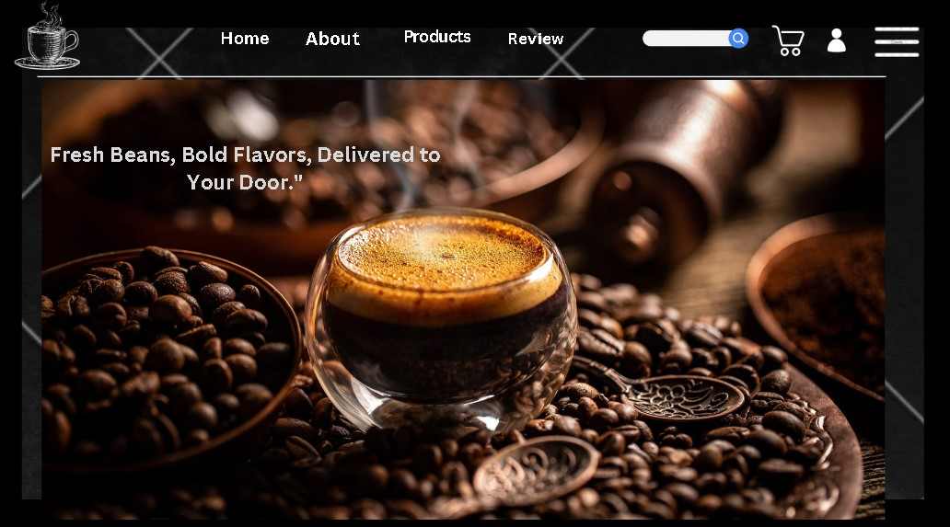

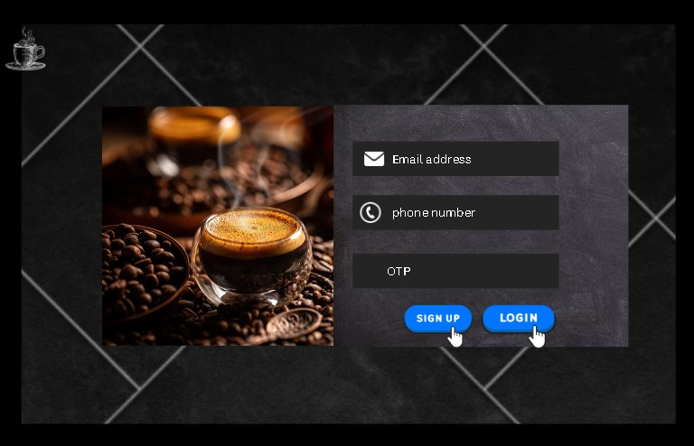

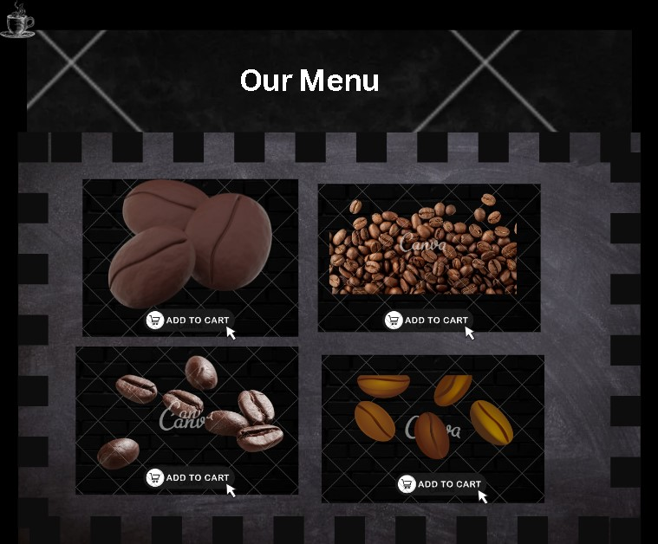

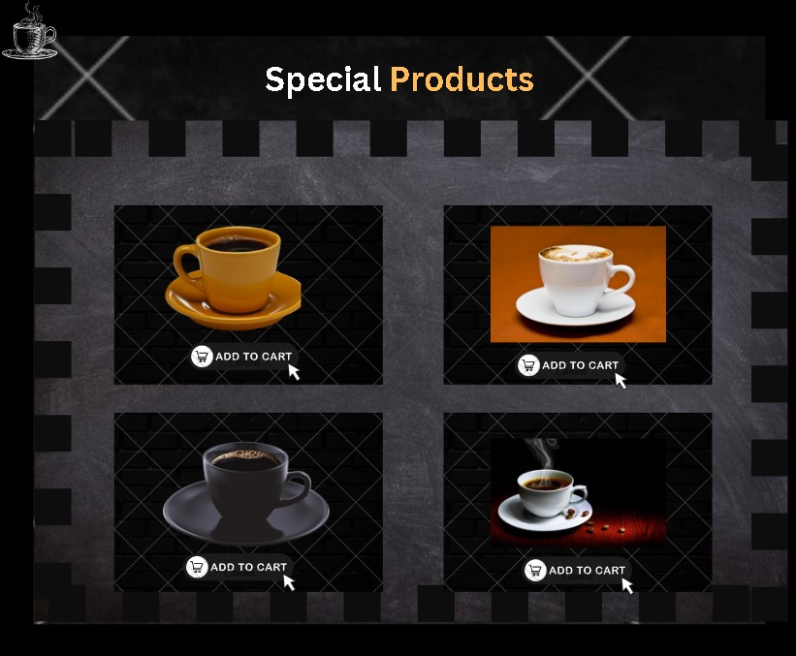

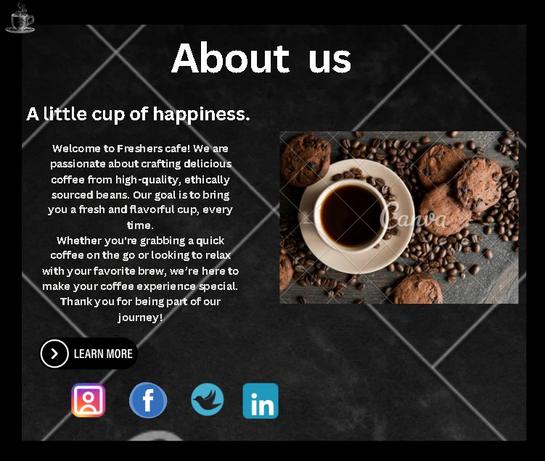

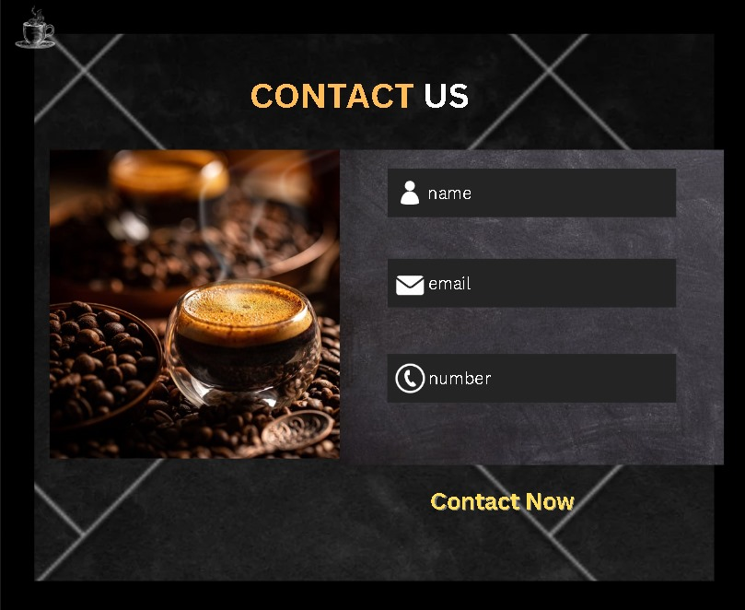

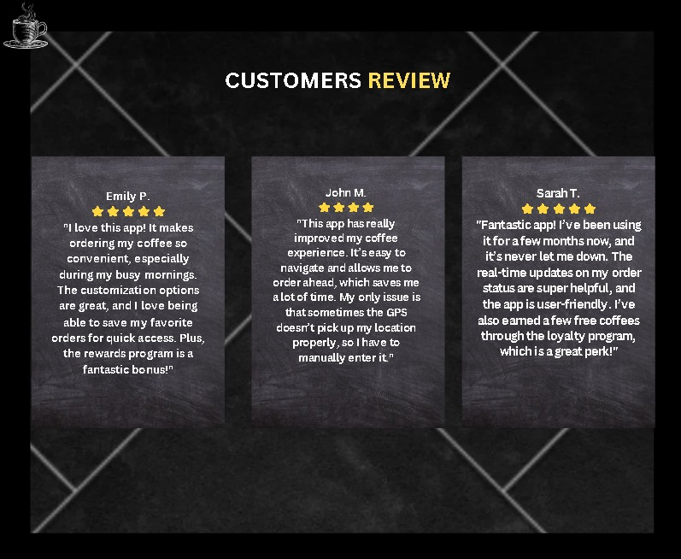

**CODE**

**<!DOCTYPE html>**

**<html lang="en">**

**<head>**

**<meta charset="UTF-8">**

**<meta name="viewport" content="width=device-width, initial-scale=1.0">**

**<title>Coffee Shop</title>**

**<link rel="stylesheet" href="https://cdnjs.cloudflare.com/ajax/libs/font-awesome/6.6.0/css/all.min.css">**

**<link rel="stylesheet" href="hci.css">**

**</head>**

**<body>**

**<section id="home" class="Home">**

**<header>**

**<div class="container" id="home">**

**<div class="logo">**

**<h1>Freshers cafe</h1>**

**</div>**

**<nav>**

**<ul>**

**<li><a href="#home">Home</a></li>**

**<li><a href="#about">About</a></li>**

**<li><a href="#products">Products</a></li>**

**<li><a href="#review">Review</a></li>**

**<li><a href="#contact">Contact</a></li>**

**<li><a href="login.html">Sign-Up</a></li>**

**<li><a href="cart.html">cart</a></li>**

**<li><a href="#blogs">blogs</a></li>**

**</ul>**

**</nav>**

**<div class="icons">**

**<a href="cart.html" style="color: inherit;">**

**<div class="fas fa-shopping-cart" id="cart-btn"></div>**

**</a>**

**<div class="dropdown">**

**<a href="javascript:void(0);" id="menu-btn" style="color: inherit;">**

**<div class="fas fa-bars"></div>**

**</a>**

**<div class="dropdown-content" id="dropdown-menu">**

**<a href="index.html#home">home</a>**

**<a href="index.html#products">Products</a>**

**<a href="index.html#about">About Us</a>**

**<a href="index.html#contact">Contact Us</a>**

**<a href="login.html">sign-up</a>**

**</div>**

**</div>**

**</div>**

**</div>**

**</header>**

**</section>**

**<section class="hero">**

**<div class="overlay">**

**<div class="hero-content">**

**<h2>FRESH COFFEE IN THE MORNING</h2>**

**<p>"Find Your Flavor, Discover Your Moment Crafted for Coffee Lovers, Made for Those Who Cherish Quality in Every Cup"</p>**

**<a href="#products" class="btn">Get It Now</a>**

**</div>**

**</div>**

**</section>**

**<section id="about" class="about-section">**

**<div class="about-content">**

**<h2>About Us</h2>**

**<h3>A little cup of happiness.</h3>**

**<p>Welcome to <strong>Fresher's Cafe</strong>! We are passionate about crafting delicious coffee from high-quality, ethically sourced beans. Our goal is to bring you a fresh and flavorful cup, every time.</p>**

**<p>Whether you're grabbing a quick coffee on the go or looking to relax with your favorite brew, we’re here to make your coffee experience special. Thank you for being part of our journey!</p>**

**<a href="#" class="btn" id="load-more-btn">Learn More</a> <!-- Assigning an ID to target it with JavaScript -->**

**<div id="extra-content"></div>**

**</div>**

**<div class="about-image">**

**</div>**

**</section>**

**<div class="extra-content">**

**<!-- This is where additional content will load when "Learn More" is clicked -->**

**</div>**

**</section>**

**<section id="products" class="special-products-section">**

**<h2>Products</h2>**

**<div class="product-grid">**

**<div class="product">**

**<img src="images/beans1.jpg" alt="Black Coffee">**

**<h3>Arabica</h3>**

**<p>₹499.99</p>**

**<button class="add-to-cart-btn"><i class="fas fa-shopping-cart"></i> Add to Cart</button>**

**</div>**

**<div class="product">**

**<img src="images/beans1.jpg" alt="Espresso">**

**<h3>Robusta</h3>**

**<p>₹599.99</p>**

**<button class="add-to-cart-btn"><i class="fas fa-shopping-cart"></i> Add to Cart</button>**

**</div>**

**<div class="product">**

**<img src="images/beans1.jpg" alt="Cappuccino">**

**<h3>Kona Coffee</h3>**

**<p>₹699.99</p>**

**<button class="add-to-cart-btn"><i class="fas fa-shopping-cart"></i> Add to Cart</button>**

**</div>**

**<div class="product">**

**<img src="images/beans1.jpg" alt="Latte">**

**<h3>Panama Geisha</h3>**

**<p>₹659.99</p>**

**<button class="add-to-cart-btn"><i class="fas fa-shopping-cart"></i> Add to Cart</button>**

**</div>**

**<!-- Add more products as needed -->**

**</div>**

**<div class="product-grid">**

**<div class="product">**

**<img src="images/beans1.jpg" alt="Black Coffee">**

**<h3>Colombian Supremo</h3>**

**<p>₹499.99</p>**

**<button class="add-to-cart-btn"><i class="fas fa-shopping-cart"></i> Add to Cart</button>**

**</div>**

**<div class="product">**

**<img src="images/beans1.jpg" alt="Espresso">**

**<h3>Tanzania Peaberry</h3>**

**<p>₹599.99</p>**

**<button class="add-to-cart-btn"><i class="fas fa-shopping-cart"></i> Add to Cart</button>**

**</div>**

**<div class="product">**

**<img src="images/beans1.jpg" alt="Cappuccino">**

**<h3>Ethiopian harror</h3>**

**<p>₹699.99</p>**

**<button class="add-to-cart-btn"><i class="fas fa-shopping-cart"></i> Add to Cart</button>**

**</div>**

**<div class="product">**

**<img src="images/beans1.jpg" alt="Latte">**

**<h3>Latte</h3>**

**<p>₹659.99</p>**

**<button class="add-to-cart-btn"><i class="fas fa-shopping-cart"></i> Add to Cart</button>**

**</div>**

**<!-- Add more products as needed -->**

**</div>**

**</section>**

**<section id="products" class="special-products-section">**

**<h2><span>Dine-In-Special</span> Coffee</h2>**

**<div class="product-grid">**

**<div class="product">**

**<img src="images/Black Coffee.jpg" alt="Black Coffee">**

**<h3>Black Coffee</h3>**

**<p>₹499.99</p>**

**<button class="add-to-cart-btn"><i class="fas fa-shopping-cart"></i> Add to Cart</button>**

**</div>**

**<div class="product">**

**<img src="images/expresso.jpg" alt="Espresso">**

**<h3>Espresso</h3>**

**<p>₹599.99</p>**

**<button class="add-to-cart-btn"><i class="fas fa-shopping-cart"></i> Add to Cart</button>**

**</div>**

**<div class="product">**

**<img src="images/cappucino.jpg" alt="Cappuccino">**

**<h3>Cappuccino</h3>**

**<p>₹699.99</p>**

**<button class="add-to-cart-btn"><i class="fas fa-shopping-cart"></i> Add to Cart</button>**

**</div>**

**<div class="product">**

**<img src="images/latte.jpg" alt="Latte">**

**<h3>Latte</h3>**

**<p>₹659.99</p>**

**<button class="add-to-cart-btn"><i class="fas fa-shopping-cart"></i> Add to Cart</button>**

**</div>**

**<!-- Add more products as needed -->**

**</div>**

**</section>**

**<!-- New Review Section -->**

**<section id="review" class="review-section">**

**<h2>CUSTOMERS <span>REVIEW</span></h2>**

**<div class="review-grid">**

**<div class="review">**

**<img src="images/user1.jpg" alt="Emily's Profile Picture" class="review-image">**

**<h3>Emily P.</h3>**

**<p class="stars">⭐⭐⭐⭐⭐</p>**

**<p>"I love this app! It makes ordering my coffee so convenient, especially during my busy mornings. The customization options are great, and I love being able to save my favorite orders for quick access. Plus, the rewards program is a fantastic bonus!"</p>**

**</div>**

**<div class="review">**

**<img src="images/user2.jpg" alt="John's Profile Picture" class="review-image">**

**<h3>John M.</h3>**

**<p class="stars">⭐⭐⭐⭐⭐</p>**

**<p>"This app has really improved my coffee experience. It's easy to navigate and allows me to order ahead, which saves me a lot of time. My only issue is that sometimes the GPS doesn’t pick up my location properly, so I have to manually enter it."</p>**

**</div>**

**<div class="review">**

**<img src="images/abhi.jpg" alt="Sarah's Profile Picture" class="review-image">**

**<h3>Ram</h3>**

**<p class="stars">⭐⭐⭐⭐⭐</p>**

**<p>"Fantastic app! I've been using it for a few months now, and it’s never let me down. The real-time updates on my order status are super helpful, and the app is user-friendly. I've also earned a few free coffees through the loyalty program, which is a great perk!"</p>**

**</div>**

**</div>**

**</section>**

**<section id="contact">**

**<h2>Contact Us</h2>**

**<form id="contact-form">**

**<label for="name">Name:</label>**

**<input type="text" id="name" name="name" required>**

**<label for="email">Email:</label>**

**<input type="email" id="email" name="email" required>**

**<label for="Phone">Phone-no</label>**

**<input type="tel" id="phone" name="phone" pattern="[0-9]{10}" required>**

**<button type="submit">Send Message</button>**

**</form>**

**<div class="confirmation" id="confirmation-message">Your message has been sent successfully!</div>**

**</section>**

**<section id="blogs" class="blogs-section">**

**<h2>Our Latest <span>Blogs</span></h2>**

**<div class="blog-grid">**

**<div class="blog-post">**

**<img src="images/blog1" alt="Blog Post 1">**

**<h3>The Art of Brewing the Perfect Coffee</h3>**

**<p class="blog-preview">**

**Discover the secrets behind brewing a cup of coffee that delights your senses. From bean selection to brewing methods...**

**</p>**

**<p class="blog-full-text" style="display: none;">**

**Discover the secrets behind brewing a cup of coffee that delights your senses. From selecting the right beans to mastering**

**brewing techniques, every step matters. Join us on a deep dive into the art and science of coffee making.**

**</p>**

**<button class="btn read-more-btn">Read More</button>**

**</div>**

**<div class="blog-post">**

**<img src="images/cofee2" alt="Blog Post 2">**

**<h3>5 Health Benefits of Drinking Coffee</h3>**

**<p class="blog-preview">**

**Did you know coffee is more than just a morning pick-me-up? Learn how your favorite drink can improve your health...**

**</p>**

**<p class="blog-full-text" style="display: none;">**

**Did you know coffee is more than just a morning pick-me-up? Studies show it can boost metabolism, improve mental**

**alertness, and even protect against certain diseases. Dive into the top five health benefits of coffee.**

**</p>**

**<button class="btn read-more-btn">Read More</button>**

**</div>**

**<div class="blog-post">**

**<img src="images/cofee3" alt="Blog Post 3">**

**<h3>Exploring the World's Best Coffee Beans</h3>**

**<p class="blog-preview">**

**Join us on a journey to explore the finest coffee beans from around the globe, and find out what makes them so special...**

**</p>**

**<p class="blog-full-text" style="display: none;">**

**Join us on a journey to explore the finest coffee beans from around the globe, including Ethiopia, Colombia, and Kona.**

**Discover what makes each bean unique and how to enjoy them to their fullest.**

**</p>**

**<button class="btn read-more-btn">Read More</button>**

**</div>**

**</div>**

**</section>**

**<!-- Footer Section -->**

**<footer class="footer">**

**<div class="footer-content">**

**<h3>Fresher's Cafe</h3>**

**<p>Thank you for visiting Freshers cafe! We look forward to serving you the best coffee experience.</p>**

**<div class="social-media">**

**<a href="https://facebook.com" target="_blank"><i class="fab fa-facebook-f"></i></a>**

**<a href="https://twitter.com" target="_blank"><i class="fab fa-twitter"></i></a>**

**<a href="https://instagram.com" target="_blank"><i class="fab fa-instagram"></i></a>**

**<a href="https://linkedin.com" target="_blank"><i class="fab fa-linkedin-in"></i></a>**

**</div>**

**</div>**

**<div class="footer-bottom">**

**<p>&copy; 2024 Fresher's Cafe. All Rights Reserved.</p>**

**</div>**

**</footer>**

**<script src="contact.js"></script>**

**<script src="cart.js"></script>**

**<script src="menu.js"></script>**

**</body>**

**</html>**

**CSS**

**const form = document.getElementById('contact-form');**

**const confirmationMessage = document.getElementById('confirmation-message');**

**form.addEventListener('submit', function(event) {**

**event.preventDefault();**

**confirmationMessage.style.display = 'block';**

**form.reset();**

**});**

**document.addEventListener("DOMContentLoaded", () => {**

**const loadMoreBtn = document.getElementById('load-more-btn');**

**const extraContentContainer = document.getElementById('extra-content');**

**loadMoreBtn.addEventListener("click", (event) => {**

**event.preventDefault();**

**loadMoreContent();**

**});**

**});**

**function loadMoreContent() {**

**const newContent = document.createElement('div');**

**newContent.classList.add('new-content');**

**newContent.innerHTML = `**

**<h3>Additional Information</h3>**

**<p>Our Philosophy**

**We believe in the art of coffee. Our philosophy is rooted in three core principles:**

**Quality: We partner with small-scale farmers and cooperatives that produce coffee of the highest quality. Each bean is carefully selected, ensuring only the best make it to your cup.**

**Sustainability: We are committed to sustainable sourcing. By supporting fair trade practices and eco-friendly farming methods, we help ensure that our farmers are compensated fairly while preserving the environment.**

**Freshness: Coffee is best enjoyed fresh. That’s why we roast our beans in small batches and ship them directly to you. Every order is roasted to order, ensuring that you receive the freshest coffee possible.**

**Our Products**

**Our extensive range includes:**

**Single-Origin Coffees: Experience the unique flavors of different regions with our single-origin offerings. Each region has its own story, and we bring that story to your cup.**

**Blends: Our signature blends combine beans from various origins, crafted to achieve a harmonious flavor profile that delights the senses.**

**Specialty Coffees: Explore our limited-edition specialty coffees that highlight rare beans and unique processing methods.**

**Accessories: We also offer a selection of brewing equipment and accessories to help you make the perfect cup at home.**

**Our Commitment**

**At [Your Brand Name], we’re not just selling coffee; we’re building a community. We value the relationships we forge with our customers and our farmers. Your feedback is essential to us, and we strive to create a customer-centric experience where every coffee lover feels at home.**

**Join Us on Our Journey**

**We invite you to join us on this coffee journey. Explore our website to discover our latest offerings, learn more about our sourcing practices, and dive into the world of coffee with us. Sign up for our newsletter for exclusive updates, promotions, and brewing tips.**

**Thank you for choosing [Your Brand Name]. Together, let’s celebrate the rich and diverse world of coffee, one sip at a time!</p>**

**`;**

**document.getElementById('extra-content').appendChild(newContent);**

**document.getElementById('load-more-btn').style.display = 'none';**

**}**

**document.addEventListener("DOMContentLoaded", () => {**

**const readMoreButtons = document.querySelectorAll(".read-more-btn");**

**readMoreButtons.forEach((button) => {**

**button.addEventListener("click", () => {**

**const blogPost = button.closest(".blog-post");**

**const previewText = blogPost.querySelector(".blog-preview");**

**const fullText = blogPost.querySelector(".blog-full-text");**

**if (button.textContent === "Read More") {**

**previewText.style.display = "none";**

**fullText.style.display = "block";**

**button.textContent = "Show Less";**

**} else {**

**previewText.style.display = "block";**

**fullText.style.display = "none";**

**button.textContent = "Read More";**

**}**

**});**

**});**

**});**

**JAVA SCRIPT**

**let cart = JSON.parse(localStorage.getItem('cart')) || [];**

**function addToCart(productName, productPrice) {**

**const existingProduct = cart.find(product => product.name === productName);**

**if (existingProduct) {**

**existingProduct.quantity += 1;**

**} else {**

**cart.push({ name: productName, price: productPrice, quantity: 1 });**

**}**

**localStorage.setItem('cart', JSON.stringify(cart));**

**alert(${productName} added to cart!);**

**}**

**document.querySelectorAll('.add-to-cart-btn').forEach(button => {**

**button.addEventListener('click', (event) => {**

**const productElement = event.target.closest('.product');**

**const productName = productElement.querySelector('h3').textContent;**

**const productPrice = parseFloat(productElement.querySelector('p').textContent.replace('₹', ''));**

**addToCart(productName, productPrice);**

**});**

**});**

**function loadCart() {**

**const cartItems = JSON.parse(localStorage.getItem('cart')) || [];**

**const cartTable = document.getElementById('cart-items');**

**let total = 0;**

**cartTable.innerHTML = '';**

**cartItems.forEach((item, index) => {**

**const itemTotal = item.price * item.quantity;**

**total += itemTotal;**

**const row = document.createElement('tr');**

**row.innerHTML = `**

**<td>${item.name}</td>**

**<td>₹${item.price.toFixed(2)}</td>**

**<td>${item.quantity}</td>**

**<td>₹${itemTotal.toFixed(2)}</td>**

**<td><button onclick="removeFromCart(${index})">Remove</button></td>**

**`;**

**cartTable.appendChild(row);**

**});**

**document.getElementById('cart-total').textContent = ₹${total.toFixed(2)};**

**}**

**function removeFromCart(index) {**

**const cartItems = JSON.parse(localStorage.getItem('cart')) || [];**

**if (cartItems.length > 0) {**

**cartItems.splice(index, 1);**

**localStorage.setItem('cart', JSON.stringify(cartItems));**

**loadCart();**

**} else {**

**alert('Cart is already empty.');**

**}**

**}**

**function checkout() {**

**if (confirm('Are you sure you want to checkout?')) {**

**localStorage.removeItem('cart');**

**loadCart();**

**alert('Thank you for your purchase!');**

**}**

**}**

**document.addEventListener('DOMContentLoaded', loadCart);**

**const checkoutButton = document.getElementById('checkout-btn');**

**if (checkoutButton) {**

**checkoutButton.addEventListener('click', checkout);**

**}**

**RESULT SCREENS**

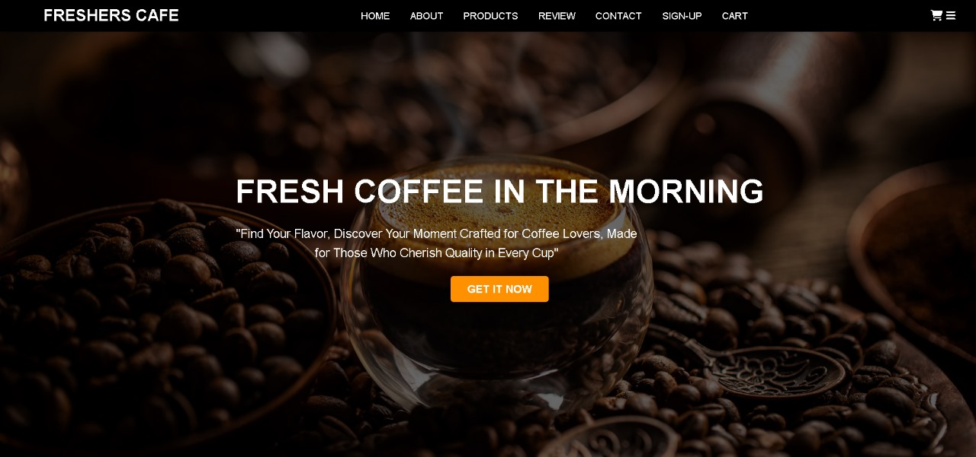

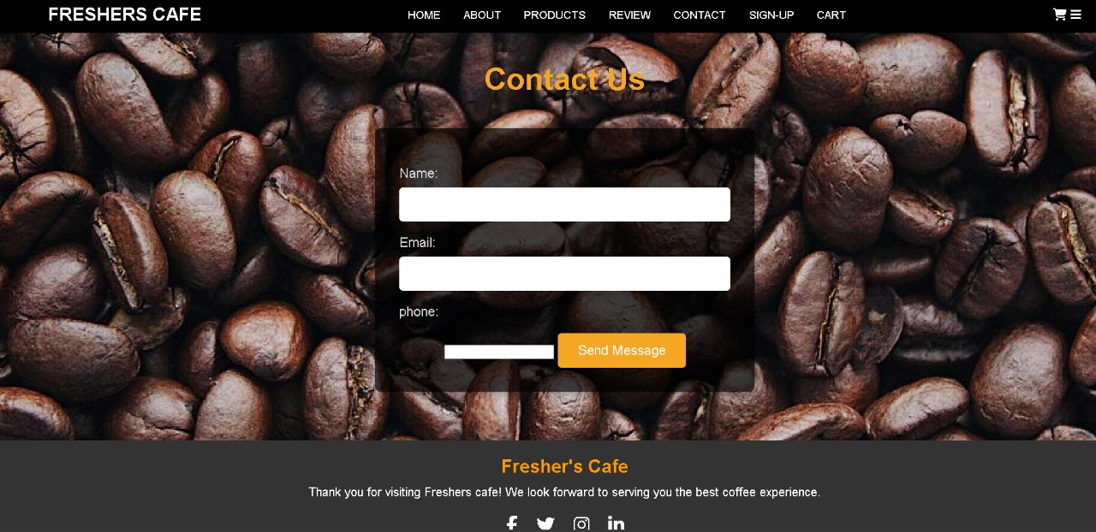

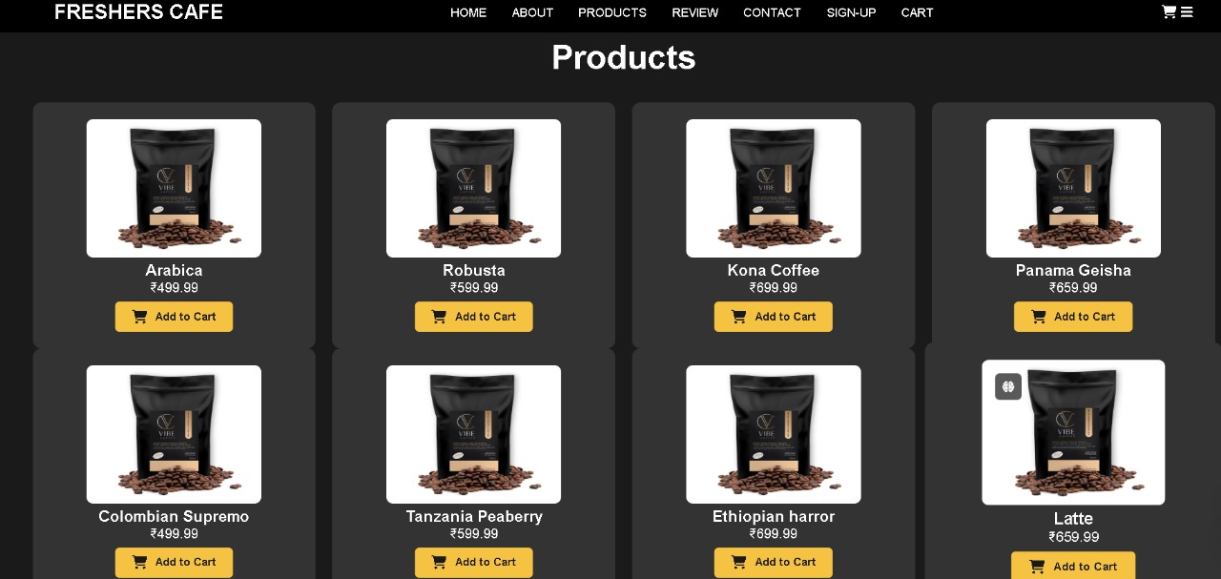

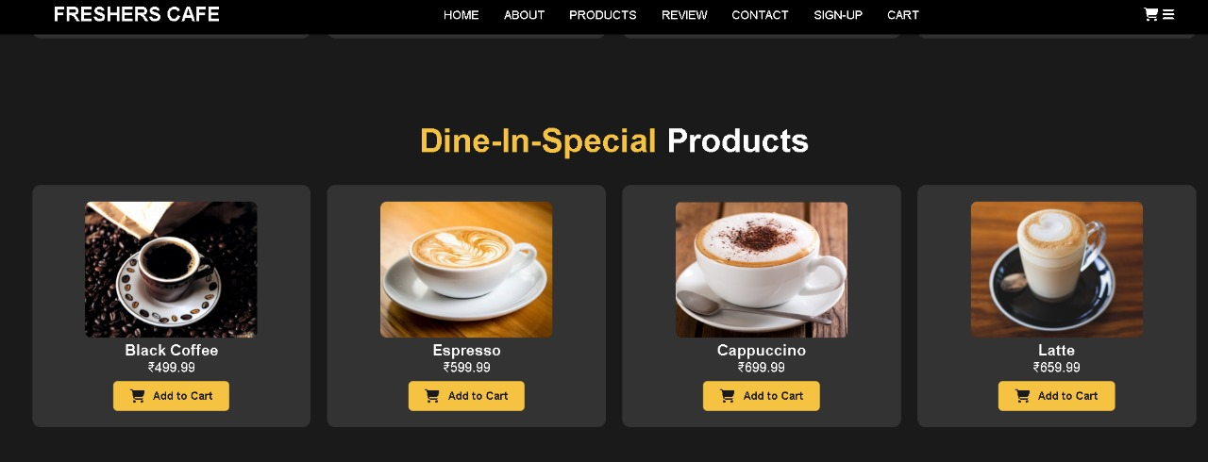

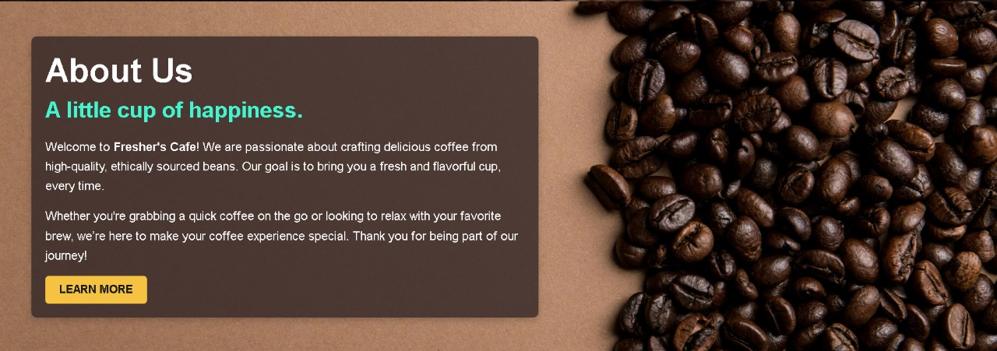

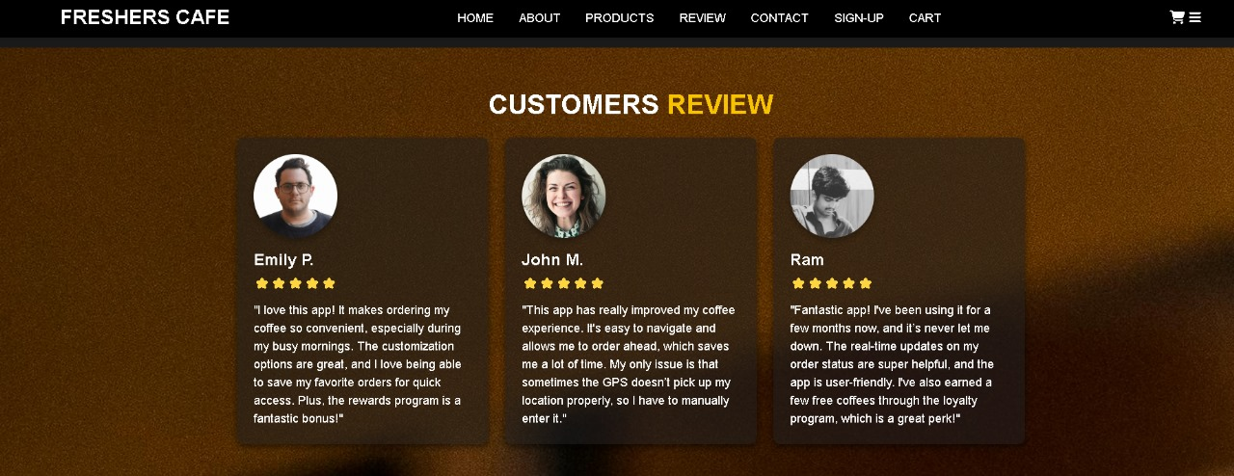

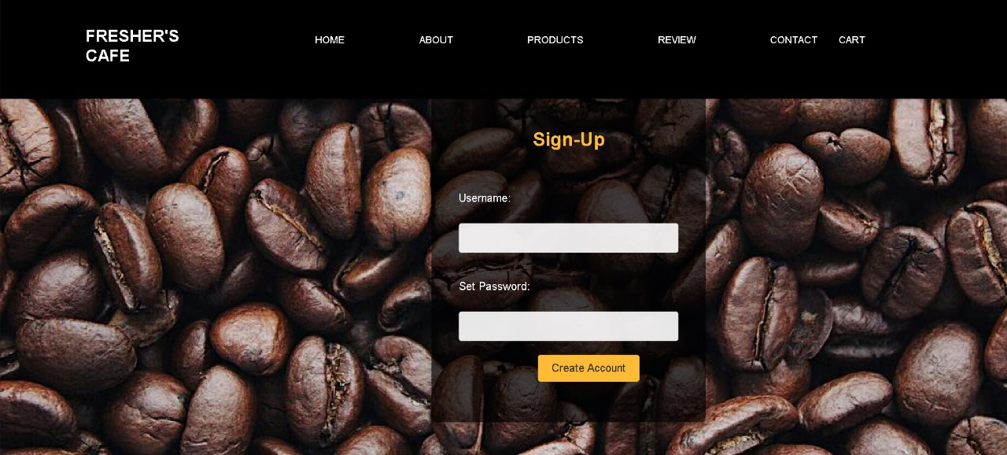

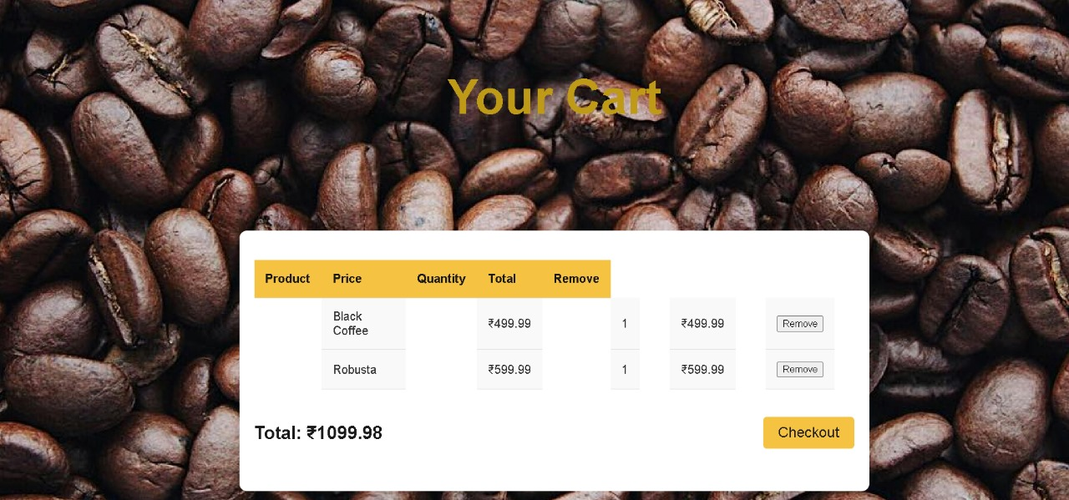

**CONCLUSION**

In conclusion, our website "FRESHERS CAFE" successfully combines HTML, CSS, and JavaScript to create an engaging and user-friendly online shopping experience. The clean layout, responsive design, and interactive features ensure seamless navigation and an enjoyable browsing experience for customers, offering them easy access to a wide variety of coffee beans.